Intentional bugs  
ACME-NEWSPAPER 2.0

|  |  |
| --- | --- |
| ****Development team**** | |
| **Identifier** | G89 |
| **Members** | Bellido Cuesta, José Manuel; Carmona Fombella, José Antonio; Viñas Ordóñez, Alicia. |
| **Testing team** | |
| **Identifier** | G21 |
| **Members** | Caraballo de la Rosa, Miguel; Izaga Ramírez, Ángel; Luna Rodríguez, Nicolás; Morato Fernández, Natalia; Ranedo Rubio, Francisco José. |
| **Indexing data** | |
| **Designers** | Bellido Cuesta, José Manuel; Carmona Fombella, José Antonio, Viñas Ordóñez, Alicia |
| **Testers** | Caraballo de la Rosa, Miguel; Morato Fernández, Natalia. |
| **Notes** |  |

|  |
| --- |
| ****Effectiveness**** |
| 5 intentional bugs found from a total number of 11 intentional bugs: 45,45% found. |

Table of contents

Bug in use case 002 – List and Create Newspapers 3

Bug in use case 004-1 – Write an Article 4

Bug in use case 004-2 – Search Articles 5

Bug in use case 009 – Create Chirps 7

Bug in use case 009 – Create Chirps 8

Bug in use case 010 – List Followers and Follow another User 9

Bug in use case 025 – List taboo Advertisements 10

Bug in use case 025 – List taboo Advertisements 11

Bug in use case 030 – Subscribe to a Volume 13

Bug in use case 033 – List and Send Messages 14

Bug in Additional tests 16

# Bug in use case 002 – List and Create Newspapers

Description

We changed the Newspapers’ publication date pattern to dd/MM/yyyy hh:mm (es) and MM/dd/yyyy (en) but in the requirements (Acme Newspaper v1.0, information requirement #2) it’s said to be only year, month and day.

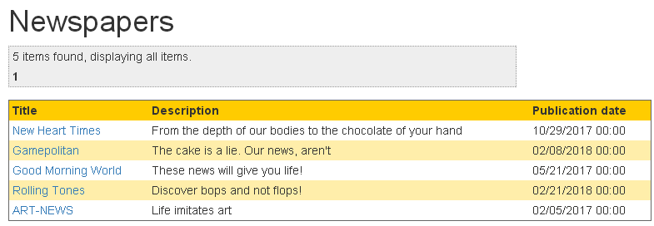Screenshot of the expected wrong results:

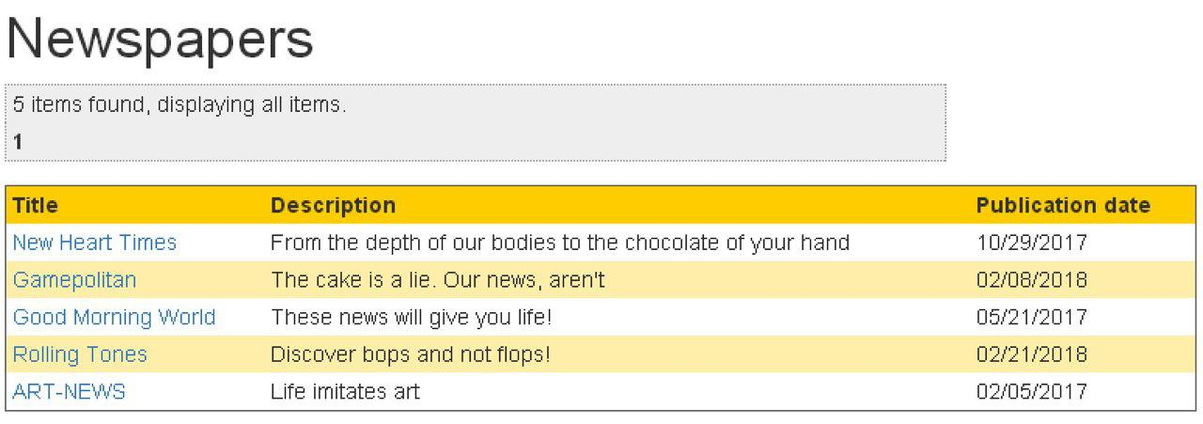

Screenshot of the correct results:

Results

We made it explicit on Test #004 from UC002 to check that the pattern was dd/MM/yyyy (es) and MM/dd/yyyy (en).

The testers reported on this error specifying the wrong patterns that they found.

# Bug in use case 004-1 – Write an Article

Description

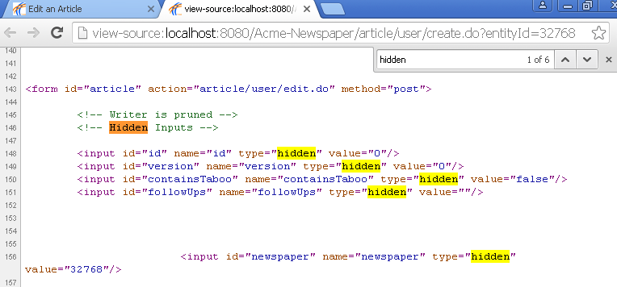We left some hidden information in the HTML from the view to create an Article: its containsTaboo, followUps and newspaper properties.

Screenshot of the expected wrong results:

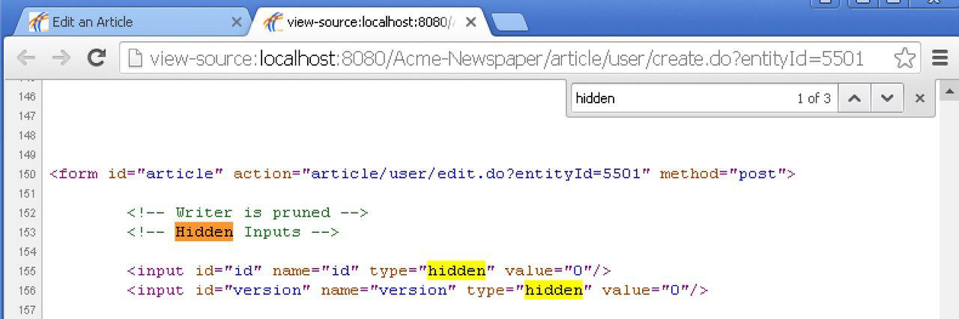

Screenshot of the correct results:

Results

We made it explicit on Test #006 from UC004-1 to search in the HTML for any hidden information.

The testers didn’t report on this error and wrote down it worked as expected (no “hidden” information found).

# Bug in use case 004-2 – Search Articles

Description

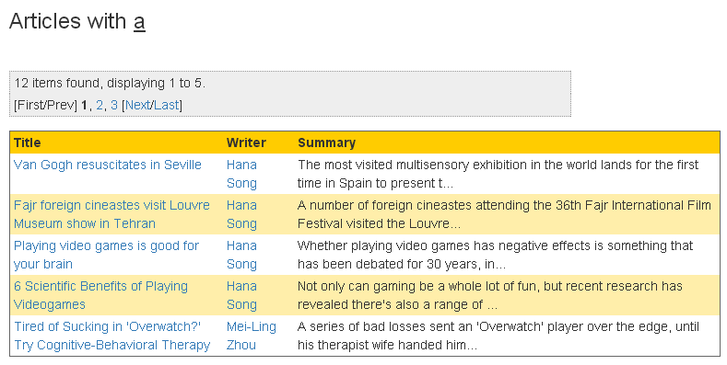We removed a column from the Article’s listings: the newspaper it belongs to, but included that column in the acceptance tests as mandatory information to be shown.

Screenshot of the expected wrong results:

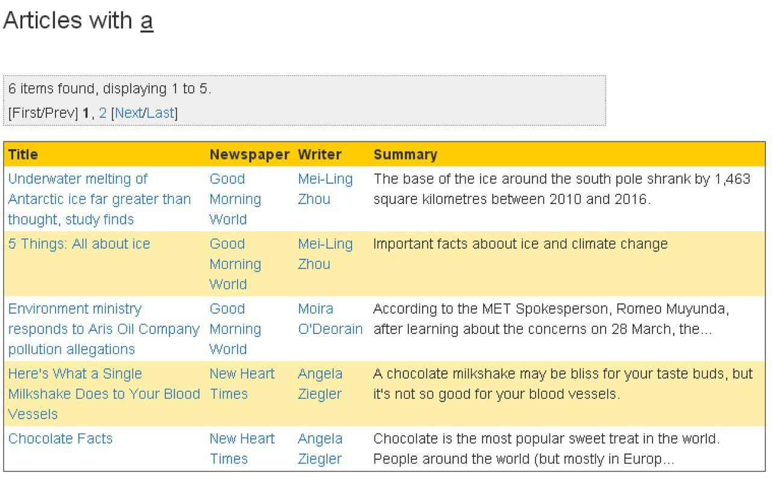Screenshot of the correct results:

Results

We made it explicit on Test #001 from UC004-2 that the listings must show title, summary, writer and newspaper.

The testers reported on this error and wrote down that the newspaper information was missing.

# Bug in use case 009 – Create Chirps

Description

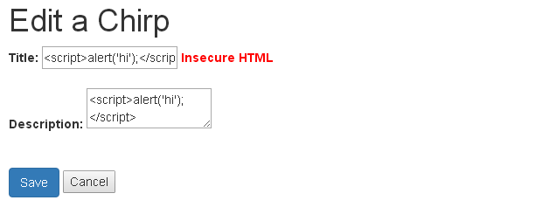We removed the @SafeHtml annotation from the description of domain.Chirp so that XSS could be carried out on that property. Thus, no error message is shown when you try it.

Screenshot of the expected wrong results:

Screenshot of the correct results:

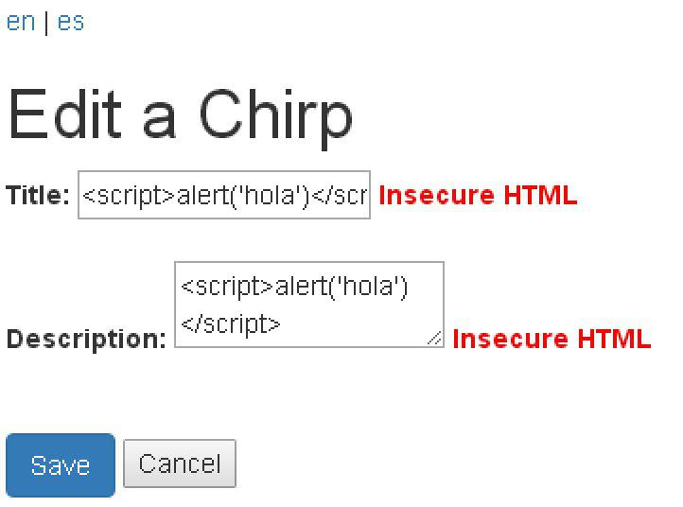

Results

We made it explicit on Test #004 from UC009 to try XSS in the create of a Chirp by entering “<script>alert(‘Hi!’);</script>” in all of its properties and check that the “Insecure HTML” error is shown in all of them.

The testers reported on this error and wrote down the error message was only shown for the title property.

# Bug in use case 009 – Create Chirps

Description

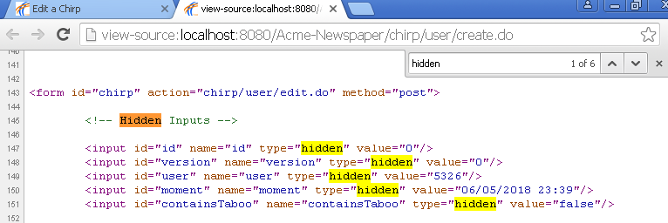We left some hidden information in the HTML from the view to create a Chirp: its user, moment and containsTaboo properties.

Screenshot of the expected wrong results:

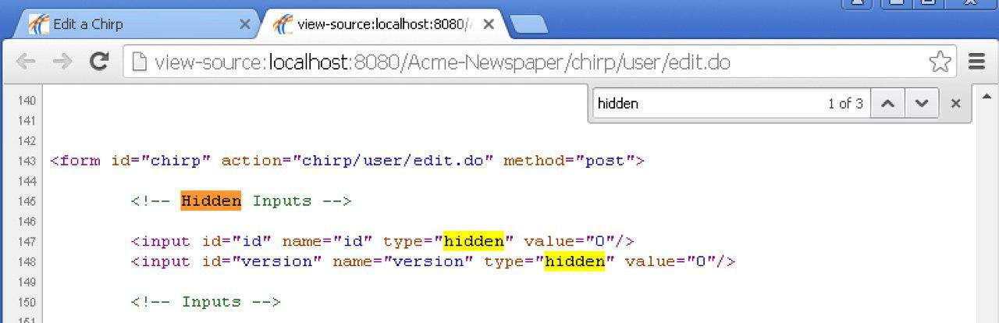

Screenshot of the correct results:

Results

We made it explicit on Test #005 from UC009 to search in the HTML for any hidden information.

The testers didn’t report on this error and wrote down it worked as expected and none of the following parameters were shown in the view: id, version, user, moment and containsTaboo.

# Bug in use case 010 – List Followers and Follow another User

Description

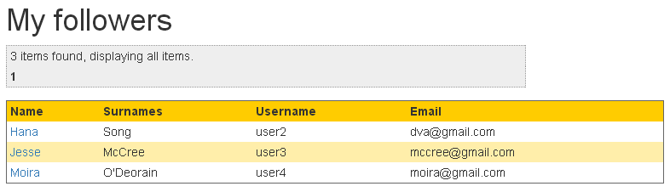We removed the sortable attribute from the username and surname columns in the Users’ listings, but included that functionalities in the acceptance tests as mandatory.

Screenshot of the expected wrong results:

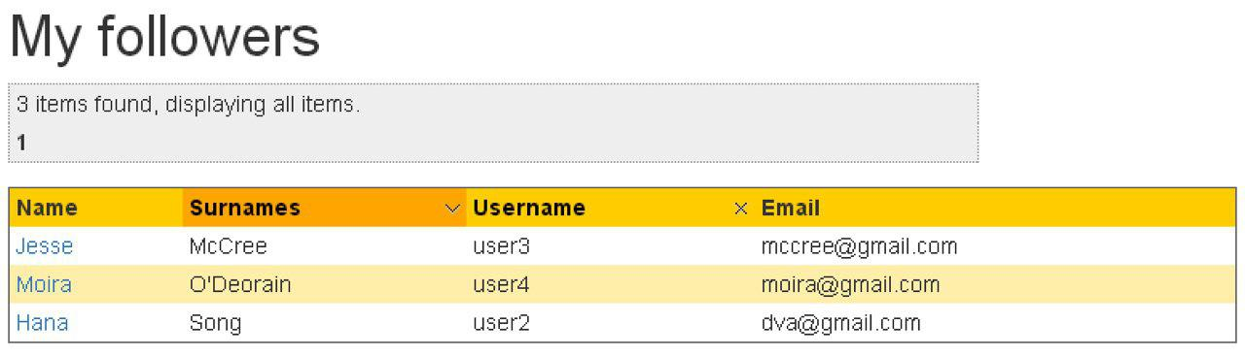

Screenshot of the correct results:

Results

We made it explicit on Test #003 from UC010 to try sorting for the surnames and username columns.

The testers reported on this error and wrote down none of the asked sorting were implemented.

# Bug in use case 025 – List taboo Advertisements

Description

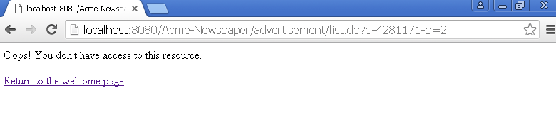We changed the requestURI attribute from the table of taboo Advertisements, so that the administrator didn’t have access to the pagination links because the URLs don’t follow the pattern “administrator/advertisement/list.do”.

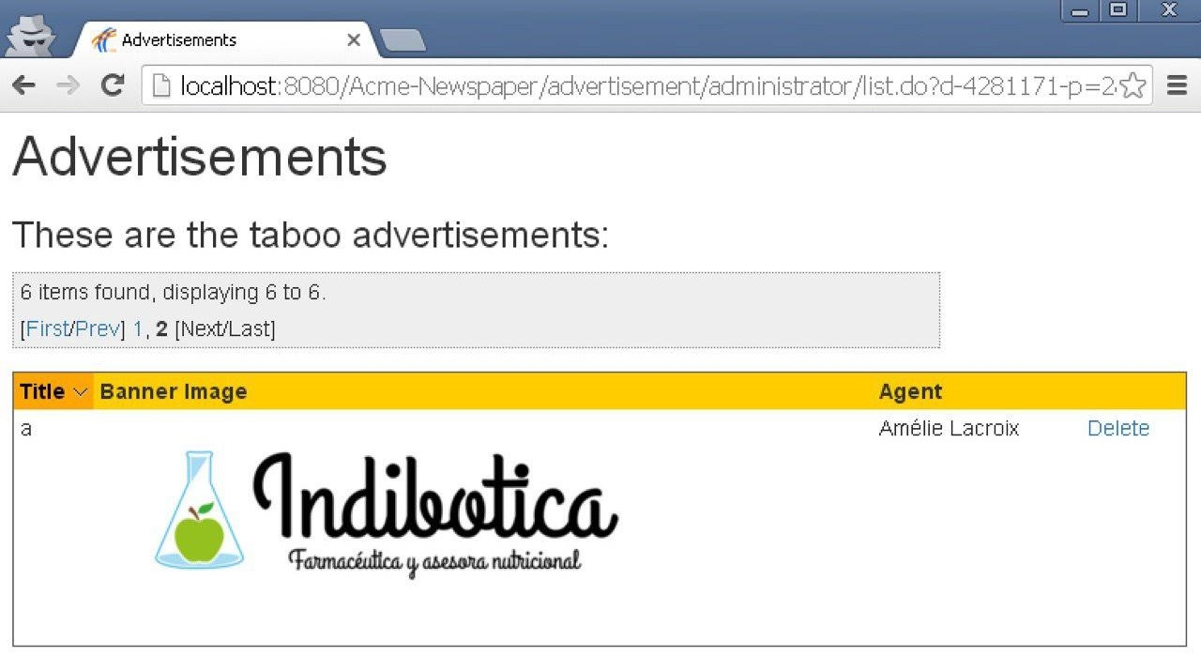Screenshot of the expected wrong results:

Screenshot of the correct results:

Results

We made it explicit on Test #002 from UC025 to check every pagination link.

The testers didn’t report on this error and wrote down that the result was the expected (no exception or error thrown).

# Bug in use case 025 – List taboo Advertisements

Description

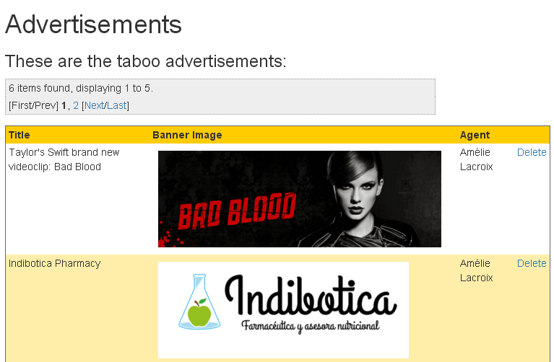We removed the sortable attribute from the title column in the Advertisements’ listings, but included that functionality in the acceptance tests as mandatory.

Screenshot of the expected wrong results:

Screenshot of the correct results:

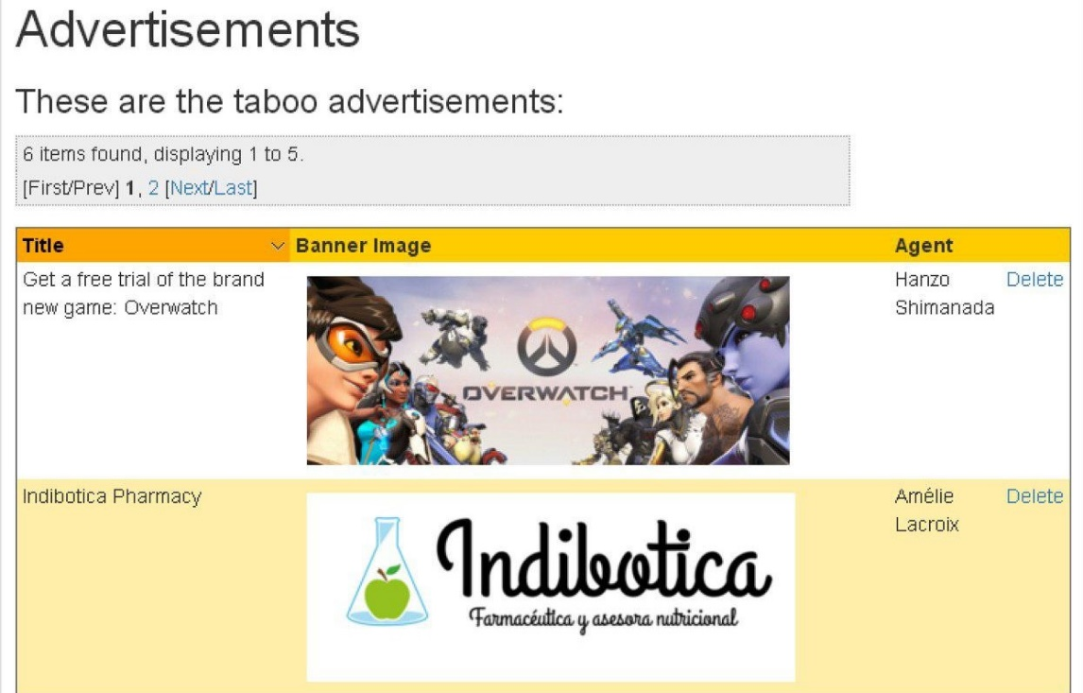

Results

We made it explicit on Test #003 from UC025 to try sorting for the title column.

The testers reported on this error and wrote down the asked sorting wasn’t implemented.

# Bug in use case 030 – Subscribe to a Volume

Description

We changed the URL to which the cancel button redirects in the “subscribe to a Volume” view. The wrong URL we used was: “volume/custom3r/display.do?volumeId=*” and the correct one is: “volume/customer/display.do?volumeId=*” (the display of the volume you were going to subscribe to).

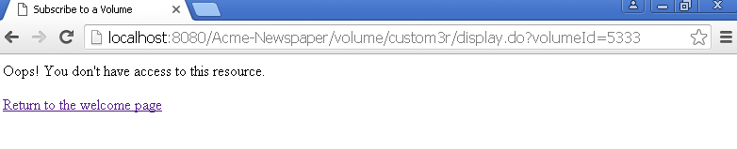Screenshot of the expected wrong results:

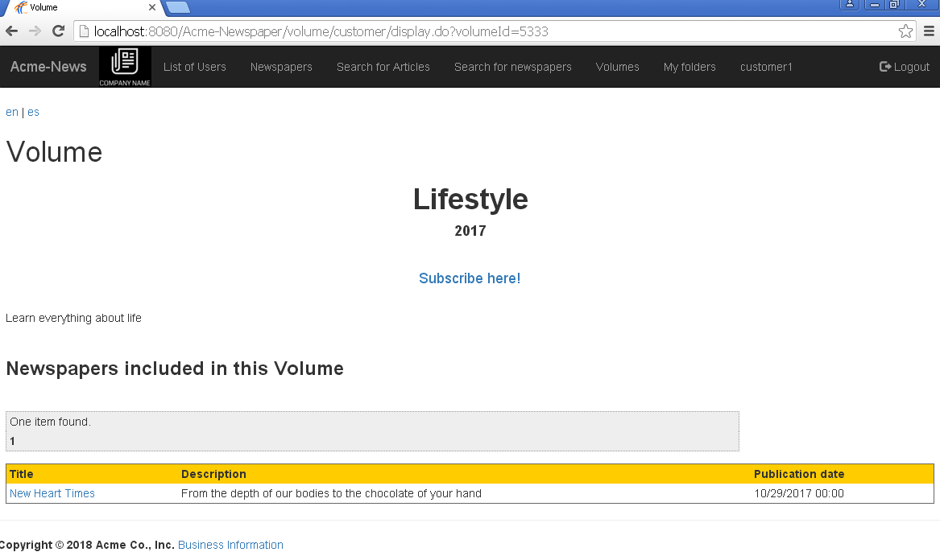Screenshot of the correct results:

Results

We made it explicit on Test #002 from UC030 to check the cancel button in case you’ve already entered invalid data.

The testers didn’t report on this error and wrote down that the result was the expected (error messages shown and returned to the display view of the volume when pressing the cancel button).

# Bug in use case 033 – List and Send Messages

Description

We changed the folder in which the received message is saved when it contains taboo words so that if any actor receives a message that contains taboo words it is received in the In Box folder instead of receiving it in the Spam Box folder.

Screenshot of the expected wrong results:

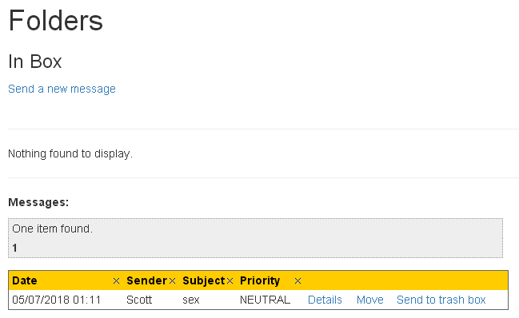

Screenshot of the correct results:

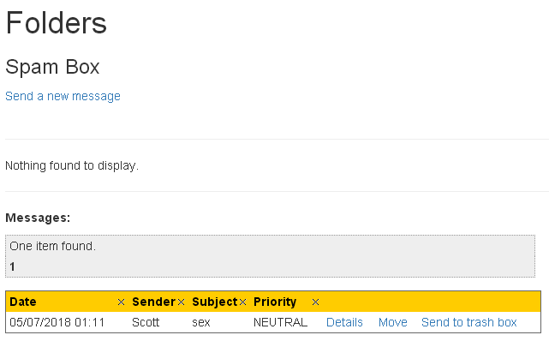

Results

We made it explicit on Test #007 from UC033 to check that if you send a message containing a taboo word, like “sex”, in its subject or body, the receiver should get the message in her Spam Box.

The testers didn’t report on this error and wrote down that the result was the expected (sender gets the message in the Out Box and recipient in the Spam Box).

# Bug in Additional tests

Description

We wrote a random message in English for one of the options of the Spanish menu.

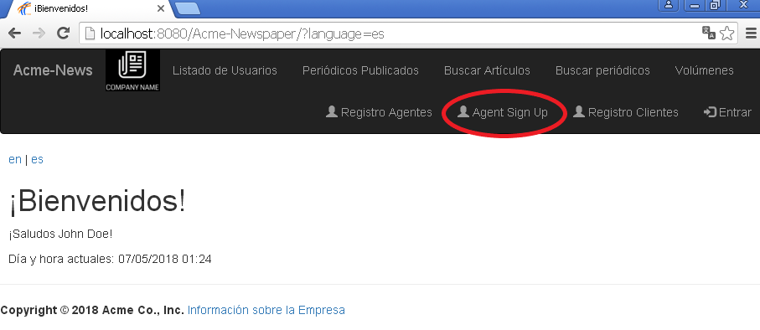Screenshot of the expected wrong results:

Screenshot of the correct results:



Results

We made it explicit on Test #900 from the Additional test to try the system in Spanish and check that all the messages were written in Spanish.

The testers didn’t report on this error and wrote down that the messages were shown in Spanish.